مشخصات cv | عنوان | ردیف
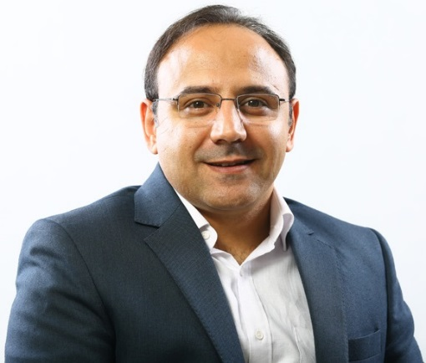  دکتر امیر نوروزی  پست الکترونیکی: a.norouzy@nigeb.ac.ir  آدرس اینترنتی:  تلفن: 02144787349  آدرس: بزرگراه همّت غرب، بلوار پژوهش، پژوهشگاه ملی مهندسی ژنتیک و زیست فناوری  طبقه همکف، پژوهشکده صنعت و محیط زیست | مشخصات فردی | 1
1382-1378- کارشناسی رشته شیمی کاربردی، دانشگاه آزاد اسلامی واحد تهران مرکز  1386-1383- کارشناسی ارشد رشته بیوشیمی بالینی، دانشگاه علوم پزشکی بابل  1393-1389- دکتر، رشته بیوتکنولوژی گرایش بیوشیمی، دانشگاه یاکوبس، آلمان | سوابق تحصیلی | 2
Research Grants  - Synthesis and Study of Blood-brain Barrier Penetrating Peptides, awarded by National Institute of Genetic Engineering and Biotechnology (NIGEB) 2019  - Synthesis and Comparative Study of Novel and Unspecific Cell-penetrating Peptides for Carrying Drugs and Fluorescent Probes into Cells, awarded by Iran National Science Foundation (INSF) 2018  - Synthesis Oligoasparatate and Oligoarginine Peptides and Compare their Cell-penetrating Capability, awarded by National Institute of Genetic Engineering and Biotechnology (NIGEB) 2018  - Synthesis and Dynamic Evaluation of Super Flexible Peptides for Binding to Hydrophobic Guest-molecules, awarded by National Institute of Genetic Engineering and Biotechnology (NIGEB) 2017  - Design and Synthesis new Oligopeptides Against Tumor Antigenes, awarded by National Elites Foundation 2016  Supervised Dissertations  - Synthesis, penetration assessment and study of the effect of blood-brain barrier shuttle peptides on the expression of Nrf2 gene, 2022, Ph.D  - Comparing the Cell-penetrating Efficiency of the Short-peptides with Opposite Electric Charges, 2020, M.Sc  - Synthesis of a Labeled Peptide and Study its Supramolecular Binding to p-Sulfonatocalix[4]arene and Curcumin Molecules, 2019, M.Sc  - Modified Mart-1 peptide for binding to HLA-A*0201 on MCF7 cells, 2019, M.Sc  - Synthesis and Dynamic Evaluation of Supper Flexible Peptides, 2018, M.Sc  - Comparative Study of MOG with Cuprizon in EAE Mice Model, 2017, M.Sc  Positions and Projects  2004 M.Sc. Thesis: Preparation & characterization of structural and catalytical properties of immobilized acetylcholinesterase. (Department of biochemistry and biophysics, Babol University of medical sciences, Babol/Iran)  2008, Internship:  - Chemically synthesis peptide silaffin R5 for biomineralization and imaging of silica particles and eGFP expression in E.Coli. (TUM-Munich, Germany)  2009, Researcher:  - Studying scorpion’s toxin effect on metabolism and histology of Balb-C mice. (Pasteur Institute of Iran)  2010, PhD Thesis (Two Main Projects):  - Indicator Displacement Assays in Live Cells.  - Polypeptide Dynamics and Structure Studies Simultaneously by Collision-induced Fluorescence Quenching and Resonance Energy Transfer in the 10-Å Domain.  (Jacobs University Bremen, Germany)  2015, Researcher (at NIGEB):  - Technology development for semi-industrial synthesis and US-pharmacopeia trial of Leuprolide acetate, a peptide-based drug.  - Design and synthesis of novel oligopeptide-based drugs against tumor antigens  2017, Faculty member at NIGEB  - Synthesis and Study Biological Function of Blood-brain Barrier Penetrating Peptides  - Evaluating the Binding Affinity of the Labeled Peptides to HLA-A2  - Design and Synthesis of Novel Cyclic Cell-penetrating Peptides  - Pharmacopeia Trial of Leuprolide Acetate  - Supervising EU Pharmacopeia Tests on Growth Hormone | سوابق پژوهشی | 3
- پپتید های حامل دارو علیه سلول های سرطانی  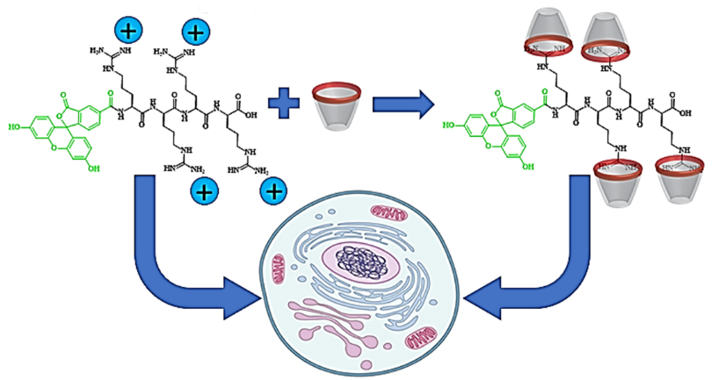  - واکسن های سرطانی  - شاتل پپتید های سد خونی-مغزی  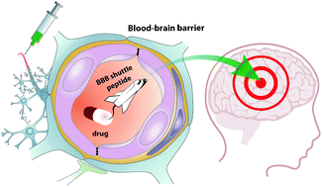 | زمینه های تحقیقاتی | 4
[1] A. Norouzy, A.I. Lazar, M.H. Karimi-Jafari, R. Firouzi, W.M. Nau, Electrostatically induced pKa shifts in oligopeptides: the upshot of neighboring side chains, Amino Acids (2022) 1-11.  [2] R. Khosravi, A. Norouzy, The Role of Pre-incubation in Formation of Supramolecular Complex Between Lucigenin and p-Sulfonatocalix [4] arene in Cell Culture Medium, Cellular Molecular Research (2022).  [3] M. Pourbaferani, S. Modiri, A. Norouzy, H. Maleki, M. Heidari, L. Alidoust, V. Derakhshan, H.S. Zahiri, K.A. Noghabi, A Newly Characterized Potentially Probiotic Strain, Lactobacillus brevis MK05, and the Toxicity Effects of its Secretory Proteins Against MCF-7 Breast Cancer Cells, Probiotics and Antimicrobial Proteins (2021).  [4] M. Shahabi, R. Hajihosseini, W.M. Nau, K.A. Noghabi, A. Norouzy, Augmenting Peptide Flexibility by Inserting Gamma-Aminobutyric Acid (GABA) in Their Sequence, International Journal of Peptide Research and Therapeutics (2020).  [5] M.D. Reihaneh Khosravi, Zahra Azizi , Mohammad Hosein Sanati ,Maryam Mohaghegh, Amir Norouzy Improving Reaction Yields of Binding Amino Acids to Wang Resin and Peptide Labeling with (5/6)-Carboxyfluorescein, Journal of Cellular and Molecular Researches (2020).  [6] M. Safaei, H. Maleki, H. Soleimanpour, A. Norouzy, H.S. Zahiri, H. Vali, K.A. Noghabi, Development of a novel method for the purification of C-phycocyanin pigment from a local cyanobacterial strain Limnothrix sp. NS01 and evaluation of its anticancer properties, Scientific Reports 9(1) (2019) 9474.  [7] M. Shakibaie, F. Tabandeh, P. Shariati, A. Norouzy, Synthesis of a thin-layer gelatin nanofiber mat for cultivating retinal cell, Journal of Bioactive and Compatible Polymers 33(4) (2018) 371-381.  [8] A. Norouzy, D. Qujeq, M. Habibi-Rezaei, Evaluation and Characterization of Free and Immobilized Acethylcholinesterase with Fluorescent Probe, Differential Scanning Calorimetry and Docking, International Biological and Biomedical Journal 1(3) (2015) 103-111.  [9] A. Norouzy, Z. Azizi, W.M. Nau, Indicator displacement assays inside live cells, Angewandte Chemie International Edition 54(3) (2015) 792-795.  [10] C.P. Carvalho, A. Norouzy, V. Ribeiro, W.M. Nau, U. Pischel, Cucurbiturils as supramolecular inhibitors of DNA restriction by type II endonucleases, Organic & biomolecular chemistry 13(10) (2015) 2866-2869.  [11] A. Norouzy, W. Nau, Synthetic macrocyclic receptors as tools in drug delivery and drug discovery, Drug Target Review (2014).  [12] A. Norouzy, K.I. Assaf, S. Zhang, M.H. Jacob, W.M. Nau, Coulomb Repulsion in Short Polypeptides, The Journal of Physical Chemistry B 119(1) (2014) 33-43.  [13] N. Abdali, E. Barth, A. Norouzy, R. Schulz, W.M. Nau, U. Kleinekathöfer, A. Tauch, R. Benz, Corynebacterium jeikeium jk0268 constitutes for the 40 amino acid long PorACj, which forms a homooligomeric and anion-selective cell wall channel, PloS one 8(10) (2013) e75651.  [14] D. Qujeq, T. Roushan, A. Norouzy, M. Habibi-Rezaei, M. Mehdinejad-Shani, Effects of dichlorvos and carbaryl on the activity of free and immobilized acetylcholinesterase, Toxicology and Industrial Health 28(4) (2012) 291-295.  [15] M.H. Jacob, R.N. Dsouza, I. Ghosh, A. Norouzy, T. Schwarzlose, W.M. Nau, Diffusion-enhanced fӧrster resonance energy transfer and the effects of external quenchers and the donor quantum yield, The Journal of Physical Chemistry B 117(1) (2012) 185-198.  [16] A. Norouzy, M. Habibi-Rezaei, D. Qujeq, M. Vatani, A. Badiei, Adsorptive immobilization of acetylcholine esterase on octadecyl substituted porous silica: optical bio-analysis of carbaryl, Bulletin of the Korean Chemical Society 31(1) (2010) 157-161.  [17] A. Norouzy, D. Qujeq, M. Habibi-Rezaei, The inhibitory effect of dissolved carbaryl in dioxane on physically adsorbed acetylcholinesterase, Reaction Kinetics and Catalysis Letters 98(2) (2009) | انتشارات | 5
2021 DAAD scholarship for former scholarship holder  2016 Postdoc scholarship: Salary and research grant from national elites foundation  2010-2013 DAAD fellowship: Research Grants for Doctoral Candidates and Young Academics and Scientists  2008 Awarded for excellent teaching at Zabol University of medical sciences.  2002, 2003 accepted among top-five students for three serial semesters in (IAUCTB), college of basic science.  2004 13th placed among thousands of volunteers in the national University entrance examination in the field of medical biochemistry.  2004 29th Placed among thousands of volunteers in the national University entrance examination in the field of biochemistry. | افتخارات | 6
 | سایر | 7
 | لینک ها | 8
 | دانلود رزومه | 9

