Mohsen farhadpour |  | محسن فرهادپور
Curriculum vitae, updated in
December 2020

Personal details |  | 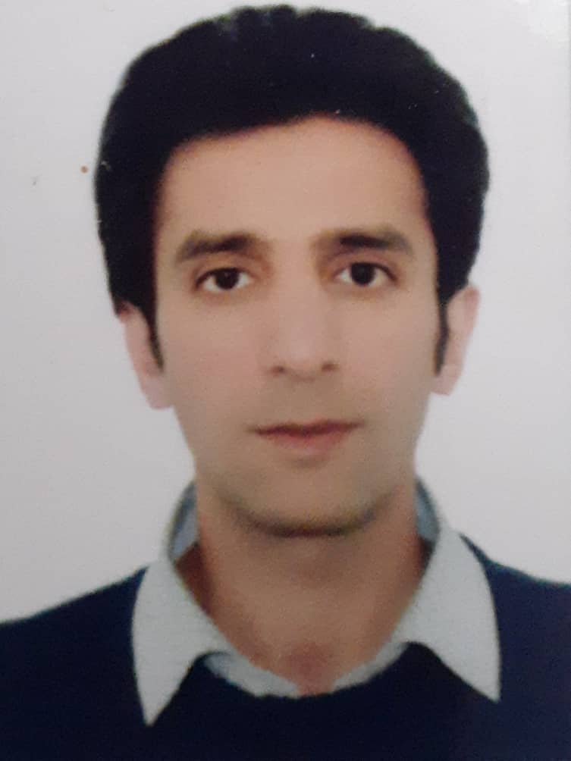
Mohsen farhadpour, PhD
phytochemistry
Academic status | Assisted Professor of phytochemistry
Currently; | Department of Plant Bio-products, National Institute of Genetic Engineering and Biotechnology, Tehran, IRAN
Date and place of birth 29 June 1987, Takab - Iran
https://scholar.google.com/citations?hl=en&user=hjTJjowAAAAJ
ORCID iD: https://orcid.org/0000-0001-7940-5884
Office | +98 21 44787305, 4422
Mobile phone | +98 914 481 4643
E-mail | m-farhadpour@nigeb.ac.ir m.farhadpour2005@yahoo.com
Language | Persian (Farsi)& Azari & English

Qualifications
High school Diploma |  | Experimental Sciences | Beheshtiti High school |  | 2008
BSc |  | Applied Chemistry | Azad uni.tabriz University, Iran |  | 2009
MSc |  | Phytochemistry | Beheshti University, Iran |  | 2012
PhD |  | Phytochemistry | Beheshti University, Iran |  | 2017
Sabbatical Research |  | pharmacology | Medical University of wien. |  | 2015
Skills
1) Practical experience on LCQ DECA LC-MSn.
2) Practical experience on MALDI-TOF TOF, 4800 AB SCIEX
3) Practical experience on analytical and preparative HPLC.
4) Practical experience on UHPLC and FPLC
5) Peptide sequencing with:
Edman degradation and Denovo sequencing

Employment history
- Peptide preparation consultant in Kimya Pajoh Dorsa company |  |  |  |  | 2016-2018
- Peptide preparation consultant in Tofigh Daru Research and Engineering Company |  |  |  |  | 2020
Teaching experiences
Undergrad. courses
General chemistry (I), General chemistry (II), Analytical chemistry, Organic chemistry (I), Organic chemistry (II)
Awards
Iran's National Elites Foundation military plan |  | 2018

Research Interests
- High-throughput phytochemical analysis of natural products
- Discovery and sequencing of new cyclic and linear peptides from natural sources
- Developing the new stationary phases for separation of polar peptides and polar compounds
- Purification of bio-active compound from natural sources

Research reports |  | طرح هاي تحقيقاتي
1 | Preparation of semi volatile aroma metabolites from Rosa damascene plant by use of enzymatic biotechnology. |  |  |  | 2019
2 | Preparation of phenolic compounds from Rosa damascene plant by use of enzymatic biotechnology. |  |  |  | 2020
BOOKS
 | 2012 | خالص سازی پروتئین های چالش برانگیز
Publications
- Cyclotides isolated from an ipecac root extract antagonize the corticotropin releasing factor type 1 receptor. M Fahradpour, P Keov, C Tognola, E Perez-Santamarina, PJ McCormick, Frontiers in pharmacology, 2017, 8, 616.
- Viola plant cyclotide vigno 5 induces mitochondria-mediated apoptosis via cytochrome C release and caspases activation in cervical cancer cells, MA Esmaeili, N Abagheri-Mahabadi, H Hashempour, M Farhadpour, Fitoterapia. 2016, 109, 162-168.
- Microwave-assisted extraction of cyclotides from Viola ignobilis. M Farhadpour, H Hashempour, Z Talebpour, A Nazanin, MS Shushtarian, Analytical Biochemistry. 2016, 497, 83-8.
- A click tyrosine zwitterionic stationary phases for hydrophilic interaction liquid chromatography
M Farhadpour, S Maghari, H Rezadoost, M Bagheri, A Ghassempour. Journal of Chromatography A. 2020, 461045.
- Evaluation of hydrophilic interaction liquid chromatography stationary phases for analysis of opium alkaloids. M Bagheri, M Taheri, M Farhadpour, H Rezadoost, A Ghassempour, Journal of Chromatography A. 2017, 1511, 77-84.
- Effect of methyl jasmonate on phenolic acids accumulation and the expression profile of their biosynthesis-related genes in Mentha spicata hairy root cultures. S Yousefian, T Lohrasebi, M Farhadpour, K Haghbeen. Plant Cell, Tissue and Organ Culture (PCTOC). 2020, 1-13.

Presentations:
1) Preparation of OC Chiral Stationary Phase. Mohammadreza Taheri, Mohsen Farhadpour, Alireza Ghassempour. 2th National Congress on Medicinal Plant 2013.
2) Comparison of Preparative Reversed-Phase and Hydrophilic Interaction Liquid 2) Chromatography for Isolation of 6-Methoxy Podophyllotoxin and Podophyllotoxin from Linum Album. Mohsen Farhadpour, Hassan Rezadoosta, Mohammad Hossein Mir jalili, Alireza Ghassempour. SPK 2014.
3) Investigation of inhibitory effect of Cyclotides on neuropeptide G-protein coupled receptors. 2th International Congress of Peptide 2016
4) Non covalent interaction study between Curcumin and Snake venom using Mass Spectrometry. zeinab Jalali, Mohsen Farhadpour, Parviz Ghezello and Alireza Ghassempour. 6th National Congress on Medicinal Plant 2017

Workshops
1) Workshop on Fast Protein Liquid Chromatography, Knauer Company, Tehran, Iran.
2) Workshop on Liquid Chromatography from Laboratory to Industry, Medicinal plants and Drug research institute, Tehran, Iran.
3) Workshop on purification of peptide, Medicinal plants and Drug research institute, Tehran, Iran. , Des 2014
4) Workshop on LC-MS, LC MS/MS, Medicinal plants and Drug research institute, Tehran, Iran.
5) Workshop on Chiral chromatography, Medicinal plants and Drug research institute, Tehran, Iran.
6) Workshop on new methods in liquid chromatography and related techniques, Medicinal plants and Drug research institute, Tehran, Iran.

